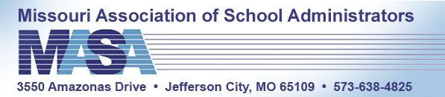
WEST-CENTRAL MISSOURI ASSOCIATION OF SCHOOL ADMINISTRATORS

WEST-CENTRAL MISSOURI ASSOCIATION OF SCHOOL ADMINISTRATORS
EDUCATIONAL SCHOLARSHIP APPLICATION
2022

Eligible applicants must be a Missouri high school senior in a West-Central member school district planning to major in education.

Applicants may attach information to the application in lieu of typing or writing it on the application.

- Personal Information

________________________________________________ ________________
University/College Applicant Will Attend Designated Major

________________________________________________ __________________
Applicant’s Name (First, Middle, Last) School District

___________________________________________________________________________
Home Address City Zip Code

__________________________________________ _________________________
Father’s Name Occupation

__________________________________________ _________________________
Mother’s Name Occupation

- School Information

Class Rank: ____________________ G.P.A.: ________________________
(List both rank and number in class, i.e. 1/50) (4 point scale)

School Activities (List all the school activities you were involved in during grades 9-12)
________________________________________________________________________________________________________________________________________________________________________________________________________________________________________________________________________________________________________________________________________________________________________________________________________________________________________________________________________________________________________________________________________________

Honors & Awards (List all honors and awards you received during grades 9-12)
________________________________________________________________________________________________________________________________________________________________________________________________________________________________________________________________________________________________________________________________________________________________________________________________________________________________________________________________________________________________________________________________________________

Community Involvement (List all community activities you participated in during grades 9-12)
________________________________________________________________________________________________________________________________________________________________________________________________________________________________________________________________________________________________________________________________________________________________________________________________________________________________________________________________________________________________________________________________________________

Career and life goals: (Please share your rationale for wanting to become an educator and what you hope to accomplish in your life both professionally and personally)
__________________________________________________________________________________________________________________________________________________________________________________________________________________________________________________________________________________________________________________________________________________________________________________________________________________________________________________________________________________________________________________________________________________________________________________________________________________

